Live Well, Laugh Often, Love Much … and above all else Eat Well ...

for what you eat today walks and talks tomorrow
West End Food Co-op

June July August 2008 Volume 1, Issue 4
Welcoming Summer …
Being the best we can be ...
It’s Conference Time ...
Last January, it came to me that it was time to ignite the accumulated great ideas that continued to flow forth from conversations held here at the Co-op.
An invitation was sent by Gabriel Bernier of Olycap to take part in his Food Summit and Farm to Table Conference, both in conjunction with his survey of eating habits on the Peninsula. From this opening came the idea for the Community Conference, “Working with our Dreams for Economic Diversity”.
For this economic growth to occur, there needs to be motivation and optimism, and this is where the agenda has been heading ever since. We have one guest speaker, games and guest artists. An opportunity to extend our creative ideas and let them grow into small business and creative opportunities suitable for the development of initiative and potential on our part of the peninsula.

We expect there to be a new flow of creativity and renewal from the ideas and people who will pick up on our invitation.
Ideas and information for the conference are available on our web site, www.westendcoop.weebly.com .
The web site was iniatiated by Mia Boster of Port Angeles Community College through her sister, Lisa Edinger who volunteers here every second Monday. Mia cam eout here one day to show me how to do the operation and I have taken it form there. Both of these people have been extremely helpful in creating the communication for your conference.
Thanks girls.
If you miss the conference by divine providence! Then get back to us and find out what connections are available and get on in with us. It is never too late to do the right thing.
Jane
“MAY TEA”
The Co-op has been honored by the student body of the High School with an invitation to be guests of honor at the 2008 May Tea; it was a prestigious affair and thoroughly enjoyable. The award is at the Co-op for all to see.
Thank you all.
May Tea,
a prestigious affair ...



Inside this issue:

It’s Conference Time | 1
Buyers’ Club Reliability | 1
Reskeining | 2
Third Place in the CAT Team … Community Garden Support | 2
Our Store Stock, | 3
Volunteers and Future Paid Work | 3
Co-op Social Talk … About the Co-op ...News | 4

Special points of interest:
Thank you Lisa, David, Robert, Chris and Neil for the Co-op’s own van for pick up delivery .

Special points of interest:
Thank you Lisa, David, Robert and Neil for the Co-op’s own van for pick up delivery .
THANK YOU to those who are showing interest at the meetings and supporting future development of the Co-op and the Community farm.
Thank you to those who have gifted the Co-op with shelving and bulk bins. Bruce, Michelle, Dale and Maree.
Thank you to the new executive, Neil and Cathy, for having faith in our project.
Come to the Conference and share the fun.
I am excited about the future.
THANK YOU to those who are showing interest at the meetings and supporting future development of the Co-op and the Community Farm.
Thank you to those who have gifted the Co-op with shelving and bulk bins. Bruce, Michelle, Dale and Maree.
Thank you to the new executive, Neil and Cathy, for having faith in our project.
Come to the Conference and share the fun.
I am excited about the future.
Buyers’ Club Reliability ..
The Buyer’s Club option of our community store works this way.
We are using ‘Azure Standards’ from Dufur, Oregon, which delivers to PA once a month. The schedule is here at the store. Come and pick up a business card called ‘Buyers’ Club’ and on it are dates for order and delivery each month.
Sit with me at the computer as I put in your order and you see it accepted.
Pick your orders up here in Clallam Bay at the Co-op for your convenience,
Some products are in bulk, some multiple containers and some are single items. All are of a better quality of food and are commensurate with the organic standards that the FDA requires for organic registration.
Our mark up is less than PA and Sequim, as we have less overhead at this time.
We may share a bulk order with you, please ask.
Orders will need to be in by the last week of each month and pick up here at the Co-op on the next Thursday. We ask 5% of the order in handling fees.
Check out the catalog on the web at www.azurestandard.com or pick one up at the Co-op.
There is a monthly specials catalog as well.
Thank you to the people who have been ordering with us. We enjoy giving you this service.

Reskeining …
We are still having fun Reskeining,
There are eight of us enjoying the benefits of soft touch, gentle feel and lustrous color. We are all working together to achieve the quota that we get each week. The quota varies, but the enthusiasm does not. Thank you team, you are most appreciated for your reliability, consistency and enthusiasm.
I received an email the other day. It was from KC Winters, “Howzit goin’ out there in the far west end? I just pulled in a Forks Forum and read an article about the skeining that’s going on. Are you still doing artsy things? Did you have the Chinese New Year event this round?” I answered KC and found out that the email came from France, the southern region where she now has a home.
News sure does get around these days.
Mary Kay just came in and said she found out about the skeining in Arizona, where she read it on the web and the Forks Forum.
Check out www.sundarayarn.com on the web and see the newest colors and the availability of the product we work with. It is already preordered when we get it and we can't seem to get enough to supply demand. It sells the minute it hits the web site. Check out the not presently available notices on the pages!
Thank you to Sundara Yarn for
including us in her program for the
future.
It is making a lot of hearts happy.
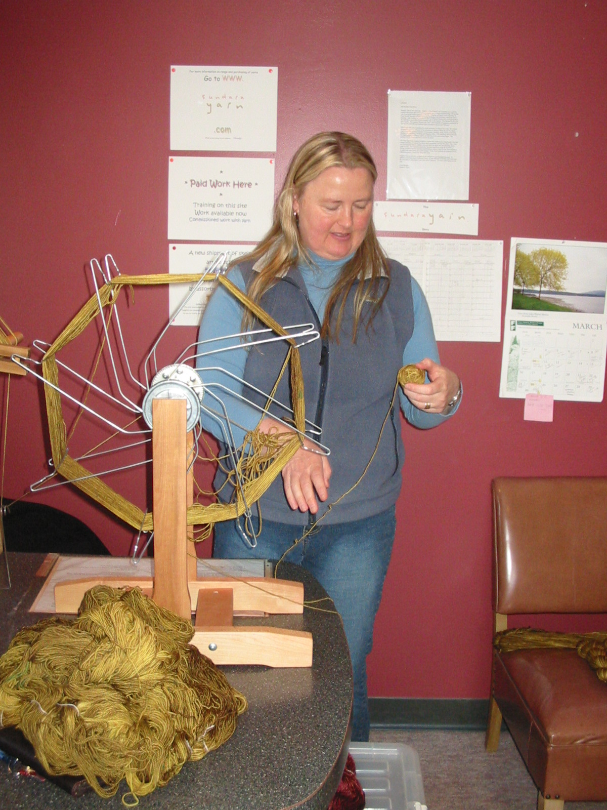
There are moments for reflection ..

The Garden,
the Co-op,
and the CAT Team Meetings ...
We have divided our energies up into three steps each month.
The first Tuesday of the month at 5.30 pm we hold the Gardeners meeting for the co-op farm/garden. It is at the Yellow Co-op Building sometimes.
The second Tuesday of each month at 5.30 pm at the Coop Yellow Building we hold the monthly Co-op meeting, all are welcome.
This is where the movements of the Co-op are discussed and prepared, celebrated and amended.
The third Tuesday of each month at 5.30 pm at the Yellow Co-op Building is the CAT Team Initiative meeting where both the Garden group and the Co-op group report back to the CAT Team Initiatives.
We are working well with this system, ideas are flowing and actions are followed up.
The gardeners are preparing their first gardening enterprise; keep your eyes peeled for the first products to reach the Co-op for sale.
We look forward to your support and interest.
Come into the Co-op and meet ‘Cedrick’ he is the living parsley plant for you to choose your freshest of herbs for your meal or to place in your window in a glass of water to keep fresh.
‘Making food fresher’. is our goal.
Working together is our plan.
Fresh, fresh, fresh ….
The Garden Group is having a fun time talking and working - organising and meeting - in order to plan and present us with a local produce supply.
They have started from very little in the way of funds and are working with what they have to give us a good fresh pesticide and herbicide-free food selection, using local resources.
Their accumulated knowledge is surfacing and the process is co-operative and active.
Neil Adams has opened his yard up to the project; it has good light, drainage and access to water and water recycling potential.
Nick Rogers has started digging this ground by hand and has produced eight garden beds from the grassed area. They are 2’ wide and 18’ long. The removed grass sod is being used to make mounds for the cucumbers and squash. The men and girls have brought in manure and mulch from Jo Gregory’s property and they thank him for his generosity.
Sasha and Autumn, Al and Nick have worked the rows to clean them up, removed the gravel from the garden area and put it back onto the driveway to fill the pot holes. THANK YOU ALL ...


Store Stock and Special Needs...
We are expanding our dry goods, and maintaining a stock of things we find that people like.
We are expanding our non-food items, and again finding out what people like and want.
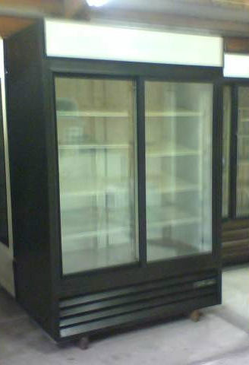
The Co-op is steadily growing in the area of bulk goods; a man who wishes to remain unidentified, is building us bulk flour and rice bins, so we can keep bulk goods clean and fresh for good price and quality.
We still have supplies of flour and rice even though there is a threatened shortage of both of these products, we have not been affected by the shortage.
We have found our commercial frigg. We can pay cash for it, it looks great. We need a pick up and delivery from Centralia to here. Anyone who knows of a transport link that we could tap into please contact the Co-op. The frig is a 2 door, 52” wide, 72” high, and 30” deep, it weighs 600 lbs, gas money can be paid
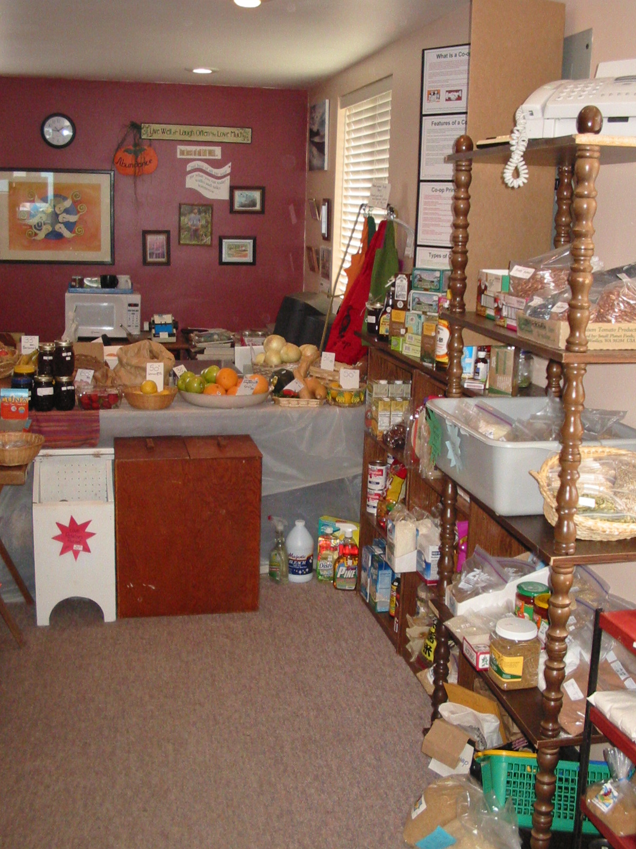
We have cheeses, vegetables, wonderful local Sol Duc Gardens salad greens, Ezekiel Bread and lots more, come on in and check us out.
We will be here for you, we are not going anywhere.
We still have a bulk honey supply that is really good, and will negotiate your favorite or special food needs to keep us all happy.
Paper Work ...
We are still growing positively. ..
as we are positively growing.
The Co-op and the Garden group are looking to work together as an enterprise.
All activities are volunteer at this time and as we grow so will our ability to employ and diversify.
We have a cut meat butcher ready to work when we have the space.
We have a commercial baker ready to supply our needs.
We have a candle maker and soap maker, and volunteers ready to do hardware when the accommodation makes itself available to us.
What we all want is there, we only have to do the foot work to make it all happen.
We now have a Co-op Van which you will see around town, it is a mid blue VW Vanagan. It came to us as a donation for pick up and delivery to and from Port Angeles and Sequim. It will be available for the delivery of orders within our own areas, as well as for the movement of the garden produce.
The Garden group is hoping to have supplies available for sale outside of our Co-op to other retailers and restaurants.
Help us to think it in


“Let’s all ‘think–in’ what we really want our towns to offer. The more of us who think the same thing the more power we give it. It’s as simple as that.”

Co-op Social Talk ...
Come and join us at the Co-op. You are welcome to come and chat, play a round of friendly Crib or Tile Rummy, or just watch the reskeining wheels go round. Tell us your dreams and wishes and let’s see where it all goes; we love people and their stories.
Let’s make this a social agenda for all and keep it that way as we grow. All gardeners are welcome to bring excess from their gardens, we have recipes to share, thoughts and ideas to talk through.
Tell us what you think the Co-op should be called. We would like it to be humorous or at least complimentary to our area. One suggestion is RUST & RELAXATION Co-op, another is SUNSHINE Co-op for the sun will always shine inside as we find support and fun with one another.
I went to a conference in Port Townsend in April about starting a Co-op, I picked up on a lot of interesting and valuable ideas about legalities and procedures.
The NWCDC will help us into our Co-op paperwork within the year. Interest is positively growing.
We are all having fun, come and see why.

WHAT IS A CO-OP?
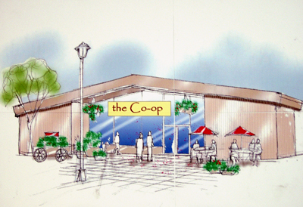
A Co-op is a member (worker and customer) owned retail business that provides high quality grocery and retail items at the lowest prices to their customers.
Planning the future.

Live Well, Laugh Often, Love Much … and above all else Eat Well ...
Cooperatives strive to enrich their communities through consumer education, volunteer discount programs, member ownership, and the creation of livable wage jobs. Cooperatives integrate their communities by selling locally grown and produced goods from small family farms and businesses as much as possible.
The Cooperative Identity:
Definition: A cooperative is an autonomous association of persons united voluntarily to meet their common economic, social , and cultural needs and aspirations through a jointly owned and democratically controlled enterprise.
Values: Cooperatives are based on the values of self-help, self-responsibility, democracy, equality, and solidarity. In the tradition of their founders, cooperative members are best to believe in the ethical values of honesty, openness, social responsibility and caring for and about others.
So — Happy People for a Happy Venture … Working together for the greater good of their own combined communities.
YOU DO NOT HAVE TO BE A MEMBER OF THE COOP IN ORDER TO PURCHASE FROM THE STORE.
NEWS ...
OUR WEB SITE www.westendcoop.weebly.com
Thank you to Mia Boster, from the Peninsula College for your personal tuition in web design We have the beginnings of our web site up and running. Home Page, Buyers Club, Conference, Wish Lists and Now Cook This, a recipe page and Blog. Please check us out and stay in touch. We will be adding more information regularly.
Community Conference is planned for June 21 & 22, the start of summer. It is entitled, ‘Working with our Dreams for Economic Diversity’, Building a Cooperative Community. We are looking to team up land and resource owners with initiative packed youth or folk looking for a new direction.
Small business opportunities and good food production, land use and environmental ideas are all welcomed. Come and see who has what and who knows what. Join the fun as we brain storm and play ourselves into a new series of choices.
The future can only look rosy.

We, the Co-op have been awarded a pre-grant approval. We have many hoops to jump in order to secure the future of this grant, but in the one to one and a half year margin, we will be up and running with a grant form the Northwest Co-op Development Center, funded by the USDA.
Stay in touch as we move on and up in our quest for a living Co-operative Store in this community.
We are currently researching Food Stamps and find we are not prepared enough yet, stay tuned. Recycle and save, we have hand painted, hand sewn Co-op Bags for sale in the store. We are looking into a future recycling set up, stay in touch for information. Below are areas we are keen to address:
Bee Keeping.
Wood Pellet industry
Kelp beauty products.
“Happy Meat”
Eggs
Good produce,
Mushrooms
Lets get into it. Stay in touch….


Working
together
for fun ...
This is your Co-op ...
Pop in often to see what is new, others do.
Live Well, Laugh Often, Love Much … and above all else Eat Well ...
West End Co-op Inc
We are here , so come on in ...
This is your Co-op ...
Pop in often to see what is new … others do.
Or just pop in, you are always welcome ...
16732 Hwy 112
Clallam Bay WA 98326
Ph: 360 963 2189
Email:westendcoop.weebly.com
Please blog us!

